Revolutionizing the Education Industry using Augmented and Virtual Reality

**Abstract:**

From ancient times, books have been a source of learning and teaching young minds about everything that happens around us. While books have been a great inspiration, they couldn't effectively provide the practical knowledge about the real world where the information which is learned in the books is actually implemented. For that, one had to go outside in the world and experience and learn by themselves. With new discoveries happening all around the globe everyday, there is so much to learn and so little time to see and experience it in the real world. That’s where Augmented and Virtual Reality are giving a boost to the learning experience and inventing new ways for more effective and efficient learning.

In this paper, we will be learning new ways in which Augmented and Virtual Reality can be used to help young minds to learn effectively and efficiently. This paper surveys the applications of virtual reality and augmented reality in the field of education and tourism.

# INTRODUCTION

Virtual Reality (VR) is a computer simulated reality which replicates the real world and simulates the users physical presence in that computer generated world while in Augmented Reality (AR) the user is present in the physical real world and the computer generated objects are superimposed upon or composited with the real world.

The traditional chalk and talk teaching method and the use of textbooks fail to engage students and lead to poor learning outcomes. Students feel it boring to just hear the lecturer talking in front of them[2]. The integration of technologies would help them in their learning process. The integration of technology also provides a means to enhance student learning and engagement in lectures. Therefore, recent studies have aimed to better understand the applications adapted during lectures from the perspective of students, including multimedia, computer-based simulations, animations and statistical software. Research by Geer and Sweeney (2012) showed that the use of a variety of media applications to explain concepts increased the understanding and supported greater collaboration between students[2].

Augmented reality and Virtual Reality is a new technology that has emerged with potential for application in education. Virtual Reality though initially had its roots in game industry is now growing in education and tourism. While a lot of research has been conducted on AR, few studies have been conducted in the education field. The number of studies on AR and VR is growing due to the effectiveness of this technology in recent years. In particular, AR provides an efficient way to represent a model that needs visualization. AR also supports the seamless interaction between the real and virtual environments and allows a tangible interface metaphor to be used for object manipulation. Virtual reality as a tool has the ability to enhance education with immersive and interactive experiences in various disciplines.

When students have difficulties in understanding the abstract concept or to visualize the concept, it leads to misconceptions. Visualization of these abstract concepts have great potential for facilitating understanding and preventing misconceptions. Kozhevnikov and Thornton (2007) found that is possible to improve students’ visualization skills with the help of visualization technologies such as virtual objects, animation, virtual environments and simulation. Furthermore, the additional context of visualizing makes it easier for students to commit the information to memory compared to rote memorization. AR and VR allows detailed visualization and object animation and displays objects and concepts in different ways and at different viewing angles which helps the students to better understand the subjects[2].

AR is a new way to improve the learning of three-dimensional shapes instead of the traditional method in which teachers use wooden objects or paper models[2].

One of the greatest uses for virtual reality in the field of history is to take virtual trips to historical places or witness historical events “first-hand”. It can also be used in the field of tourism the users use Google Cardboard and their smartphones to journey to their virtual destination and explore. The application serves as the tour guide and also contains extra information to explain certain landmarks in more detail[3].

VR can be used in Behavioral studies to recreate scenarios that would otherwise be problematic or dangerous[3].

# VIRTUAL REALITY

Virtual Reality is a technology that allows the user to navigate and interact with the virtual world in real time. Virtual environment (VE) is three dimensional environment where user can navigate and view in 360 degrees. Virtual environment is an illusion that can be seen using head mounted devices.

**Components :**

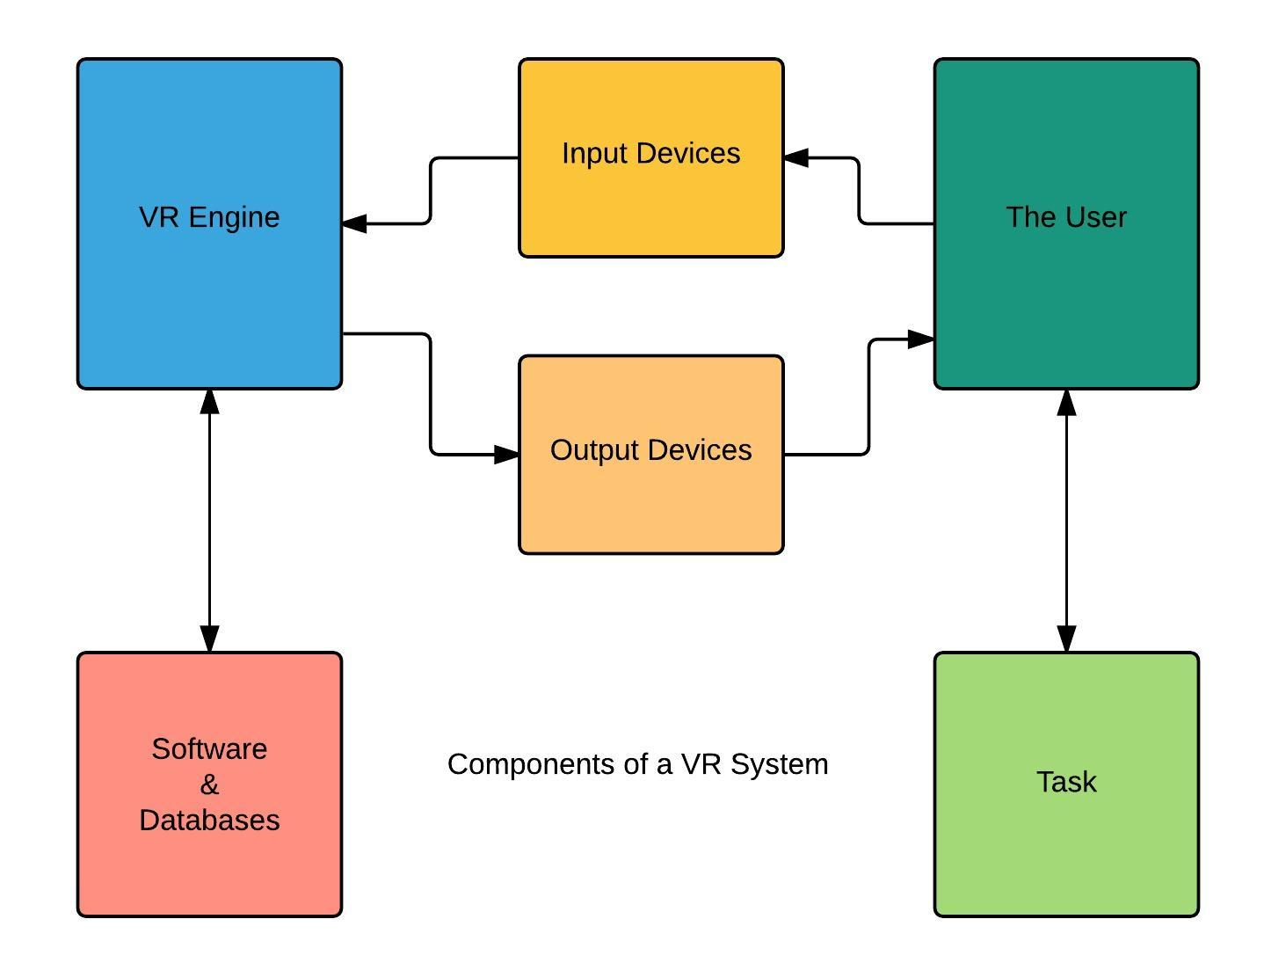

The system consists of 3 important stages, that are, software, VR engine and end users. The software stage is responsible for geometric and kinetic modelling of the virtual world. The VR engine acts as an interface between the user and the software through input output devices. Input is provided by the user with the help gyroscope and also magnetometer(compass) inside the mobile handset to register the movement of the neodymium magnet as a click option on the mobile screen. After any action performed, respective output is mapped onto the virtual world and showcased to the end user.

# AUGMENTED REALITY

Augmented Reality (AR) is a technology that aims to enhance the real environment by projecting virtual objects/models on top of it. AR as systems have the following characteristics:

1) combines real and virtual;

2) interactive in real time;

and 3) registered in 3D [1].

AR experience can be provided using mobile phones and computers. AR is different than VR in the aspect that AR extends reality rather than replacing it. Augmented Reality enhances user's perception, imagination and interaction with the real world. Thus , interactive learning is helping augmented reality in making its root in education industry.

**Components:**

Augmented reality systems are built upon on three major buildings blocks [1]:

1. Tracking and Registration

Tracking and Registration is needed to know the user’s exact location in comparison to his surroundings and also is used for tracking the exact eye and head movements of the user. This is the most complex part of the Augmented Reality technology as three major functions such as tracking the overall location, movement of the user’s head and eye and adjusting the graphics to be displayed are done with utmost precaution.

2. Display technology

Types of displays are used in AR technology

● Head Mounted Displays [HMD]

HMD keeps both the images of the real physical world and the virtual graphical world over the user’s world view.

● Handheld Displays

Such displays are small in size and will easily fit in one hand. These devices use video transparent techniques to relate the virtual world to the real world.Since they are easily portable and due to the bulk use of camera phones, they are used widely.

3. Real time rendering

Real time rendering means as the orientation of the target object changes in the real world, the orientation of the projected 3d object should also change simultaneously without any flickering.

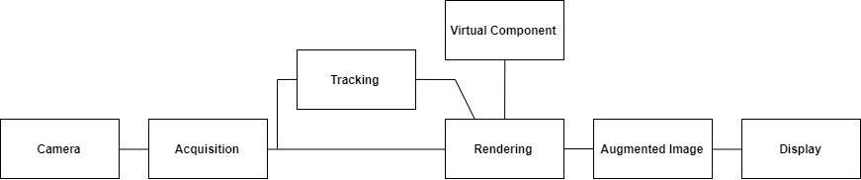

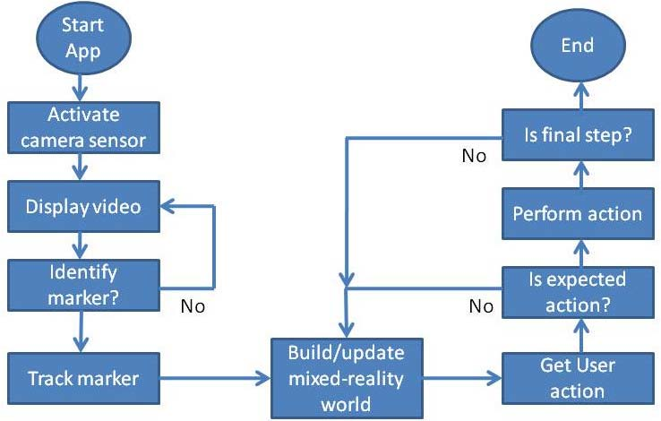

# RECENT TRENDS IN EDUCATION INDUSTRY

In mid 20th century, the world realized that for the progress of the nation it was necessary to reform the education system and move ahead from classroom teaching which used blackboards and whiteboard. But these techniques of teaching were not sufficient, as sea of information was discovered and invented daily all around the world. It was nearly impossible for young minds to access it unless it was available in the books and even then books were insufficient to cover all the information . In 1980s digital age arrived and computers were made available to the general public. Computers were used to store information in digital form which was available to the people as and when required. After this in the late 20th century, internet became popular as information was available with just a click without storing it on computer. In early 21st century, schools/colleges started becoming smart classes. Smart classes are conducted by a teacher using a viewing screen/computer that is attached to the projector. Students learn the audio-visual information that is projected on the screen. Digital learning help students understand things better. Smart classes provide efficient learning but lacked in interactive and creative learning. That’s where Augmented and Virtual Reality are giving a boost to the learning experience and inventing new ways for more effective , interactive, efficient and creative learning.

# APPLICATION OF VIRTUAL REALITY AND AUGMENTED REALITY IN EDUCATION

Medical - AR and VR technology can be used by medical students to practice surgery in controlled environment. This technology allow students to learn new skills without causing any damage to patients.

Tourism - AR can be used as a tourist guide by tourists in museums and historical places. While VR technology can provide the virtual tour of tourist places.

Architecture and Interior design - AR and VR can be used to analyse architecture for construction work and interior design. Using these technologies , an organization can not only render the resulting structure in 3D but also experience them as they would in the real world.

Military - VR and AR has been adopted by the military where it is used for training purposes. This is useful for training soldiers for war situations where they have to learn how to react in an appropriate manner.

**Proposed System**

In our proposed system we will be exploring new ways in which augmented and virtual reality could be used to provide interactive and efficient learning.

1. Tourism of historical sites

People love to visit different places with historical values but it involves spending a lot of money and time as well. Even financial conditions can be an obstacle in experiencing human made or natural wonders of the world. AR in tourism can save a lot of time and is available free of cost. By using AR, one can enjoy the scenic view of historical sites in its true form while sitting at home. Also an audio could be played along with visual effects which will give info about the historical importance of that place.

2. Story Telling

Kids are always eager to listen to stories. But it would be more fascinating and indulging for them if their favourite characters would come alive and act in front of them. AR Storytelling will bring alive characters which will tell their own stories in interactive manner. Through ‘AR Storytelling’ ,imagination skill of kids will improve which might help them in future.

3. Engineering Drawing Models for students

A compulsory subject for all engineering students, Engineering Drawing turns out to be a nightmare because of its complex 3d models. Students are not able to imagine the 3d models just by looking at the 2d drawing of the 3d model. AR in Engineering Drawing will help the students to imagine the models in real world 3d space.The AR models available will be for specific problems but it will help the students to get an idea about other similar problems.

4. Painted Cube Problem

Painted Cube is a classic logical problem in which we take a cube and paint it on all sides and cut it into pieces. For eg. 3*3*3 sided cube is cut into 27 small pieces. Then we are asked to calculate number of cubes with 3 sides, 2 sides, 1 side and no side painted cubes. It is quite simple for a simple cube but becomes complicated when we cut small cubes from big one and then paint it. Students find it difficult to imagine how the cube would appear when small cubes are removed. By introducing AR in Painted Cube problem, students will get a idea of how that cube might look like. Specific Problems will help the students to imagine the cube for other specific problems.

Final Outcome:

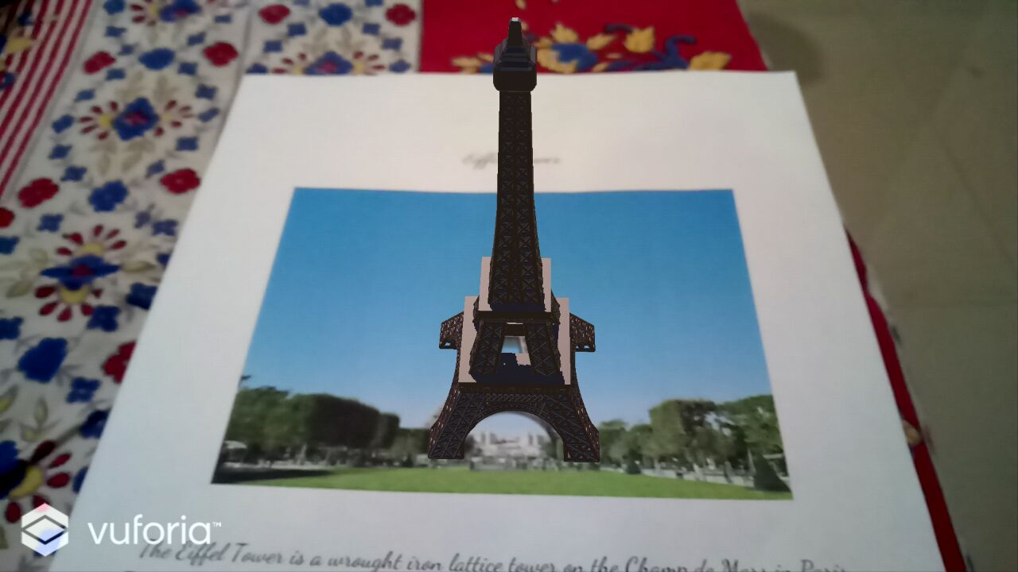 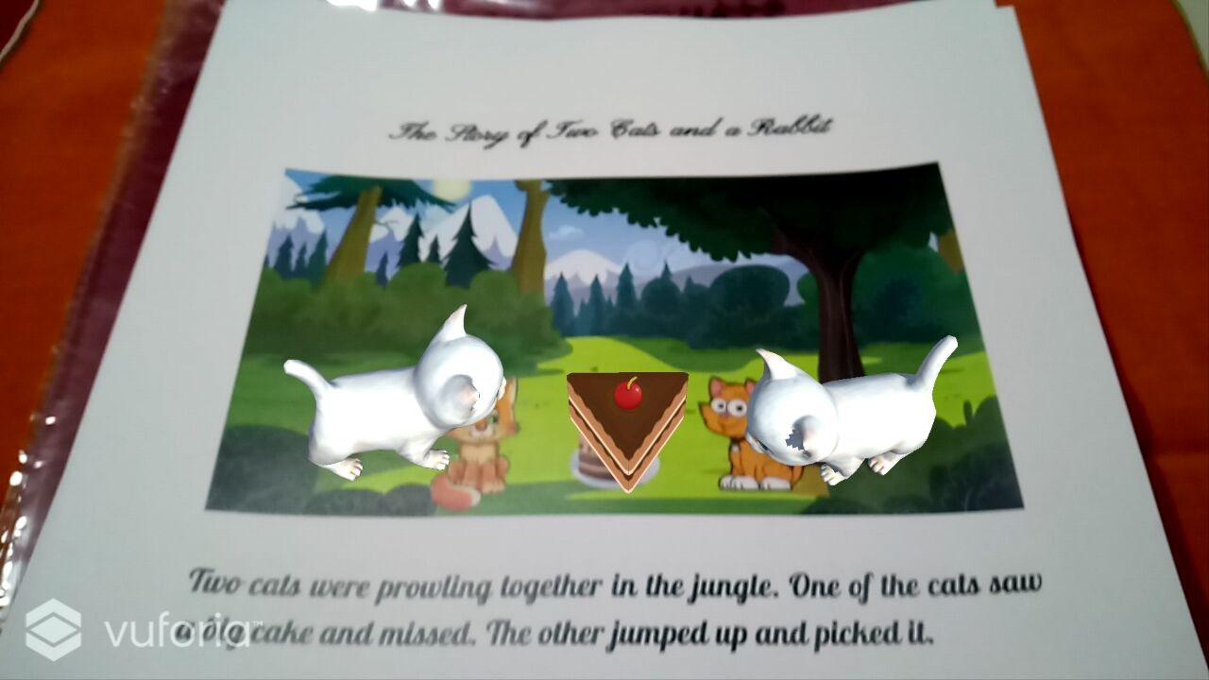

Eiffel Tower Storytelling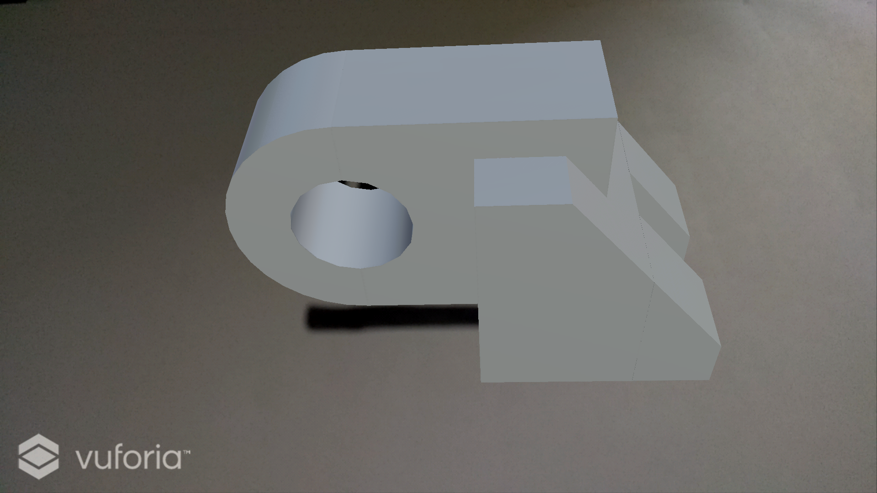 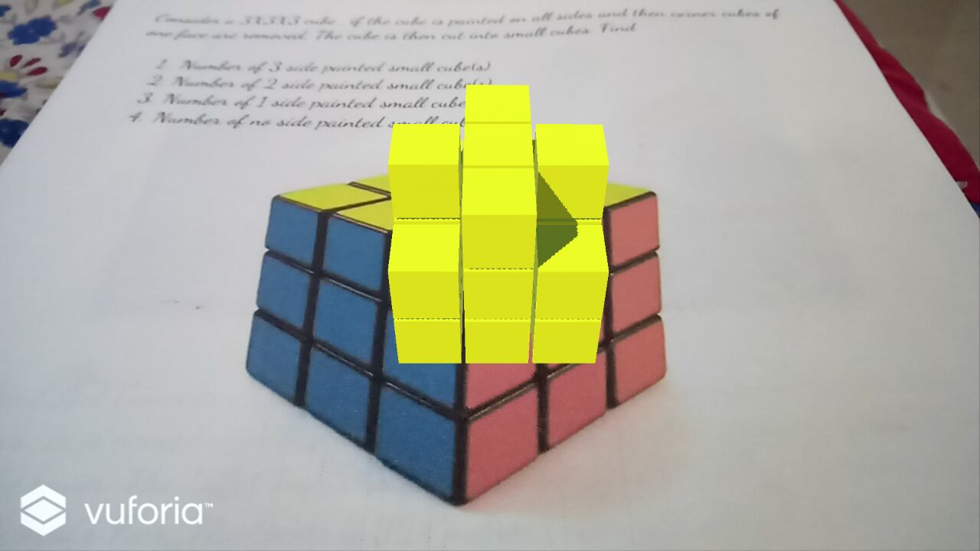

Engineering Drawing Painted Cube

**Conclusion**

Augmented and Virtual reality have many applications in every field of sciences like Education, Medical, Military, Tourism, Architecture, Interior design and much more. They both are used to solve real life problems in day to day life. In this paper, we have discussed various ways in which augmented and virtual reality can be used in education to make it more creative, interactive and efficient. The various applications discussed in detail are visiting historical sites while sitting at home, storytelling, engineering drawing models for students and painted cube problems.

**Reference**

[1]<http://www.wseas.us/e-library/conferences/2014/Malaysia/ACACOS/ACACOS-29.pdf>

[2]<http://citeseerx.ist.psu.edu/viewdoc/download?doi=10.1.1.730.8456&rep=rep1&type=pdf>

[3]<https://www.usma.edu/cfe/Literature/Boyles_17.pdf>